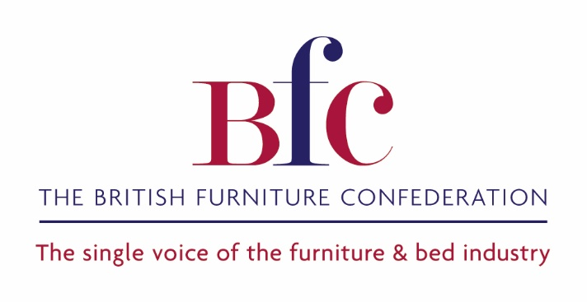
WHY EFFECTIVE FIRE SAFETY REGULATIONS FOR
UPHOLSTERED FURNITURE & FURNISHINGS MATTER

Background
The UK’s Furniture & Furnishings (Fire) (Safety) Regulations (FFFSR) were originally introduced in 1988. They require upholstered furniture - such sofas, chairs, floor cushions and beds - sold in the UK to be made with covers that resist ignition when in contact with smouldering ignition sources (such as cigarettes) and small flames (such as matches or candles). In addition the filling materials used in all upholstered furniture - including sofas, chairs, floor cushions, scatter cushions and mattresses - need to meet higher ignition requirements. These requirements are designed to slow down the spread of fire and give you more time to escape in case of fire.

While the regulations have been amended (in 1989, 1993 and 2010), the requirements have basically remained the same for 30 years. The British Furniture Confederation (BFC) has long campaigned for the regulations to be revised, recognising new materials and manufacturing techniques, while maintaining equivalent levels of fire safety.

Today, the need for the regulations is being questioned by a number of stakeholders:

- With the improvements in fire safety in the home (i.e. introduction of smoke alarms) and the reduction of smoking at home, are they relevant or even effective anymore?
- While the regulations do not require the use of fire retardants, this is the most common route to compliance. There is concern that some fire retardants may have adverse environmental or health effects.

In addition, in 2017 the Guide to the Machinery Directive was revised to state that furniture with electrical features, such as adjustable chairs and beds or rise and recline chairs for the less mobile, are now classified as machines and have to meet the Machinery Directive in full. The BFC sought advice from the Department for Industrial Strategy, Energy and Skills (BEIS) on the application of the Machinery Directive (MD) to such furniture. The guidance from BEIS was that as the MD is a full product safety directive, there are ample provisions for safety (including fire safety) and that the FFFSR, as national legislation, did not apply to such furniture. While the BFC recognise that as responsible manufacturers, UK producers are likely to meet the both the MD and the FFFSR, any product manufactured and CE marked as compliant with the MD in any country in Europe, whether it meets the FFFSR or not, could legally be sold in the UK.

Purpose of the Test
The BFC commissioned this test to assess:
- Whether the FFFSR still provide an adequate and superior level of consumer safety in the UK than elsewhere in the world.
- Whether the advice that products classed as machines under the MD, and often used by vulnerable users, do not have to meet the FFFSR, provides adequate levels of safety to these vulnerable users.

Test Samples
For the test, the BFC sourced two rise and recline chairs that were manufactured by a UK company, Sherborne Upholstery, which specialises in rise and recline seating. Both chairs were constructed to appear identical, but one was manufactured using fire resistant (FR) foam specially produced to meet UK fire regulations; while the other used non-FR foam approved for use in furniture in mainland Europe – both supplied by Vitafoam. Sherborne also sourced from their supply chain the same cover fabric, used with fire retardant treatment on the compliant sample; and without on the non- compliant one.

The chairs looked and felt identical. Both chairs performed as well as each other in comfort and support; without the appropriate labelling required by the FFFSR, there would be no way for the consumer to differentiate between the two chairs. However the flammability test had very different results.

The Test
The products were testing by Exova Warrington Fire at their Warrington laboratory. Warrington Fire was selected because:

- It is a recognised fire testing specialist;
- It has a facility that allows for the testing of full items of furniture.

Note: Warrington Fire do not have UKAS accreditation to test to the FFFSR, they are accredited to test to International Maritime standards (IMO) for furniture, which use very similar test methods to assess furniture products intended for use in ships.

The FFFSR requires each individual component (filling and fabric) to be tested separately on a representative test rig, using worst case conditions. For the purposes of the test programme, it was recognised that this would not be appropriate and full item testing was required. It is accepted that this means the test results are technically indicative only.

The test programme was only designed to assess resistance to ignition of the product. Other factors such as rate of combustion, heat load, volume of smoke and toxicity of smoke produced were not measured.

The FFFSR contain a number of different ignition sources for cover and fabrics and fillings. For the test programme a test based on Schedule 5 Part 1 of the Regulations was used. This is a test that simulates a match flame being applied to a cover fabric.

The match flame is simulated by a gas flame, which is controlled by flow rate and temperature. In the FFFSR the match flame is applied to the cover fabric, which is placed over a non-combustion modified foam on a specified test rig. For the test programme the match flame was applied to the final chair directly. The flame was placed at the intersection between the seat and back cushion. The flame was applied for 20 seconds, as defined in Schedule 5 Part 1 of the Regulations.

The Test Results
When the match flame was applied to the compliant chair, it was noted that the cover fabric started to burn on the surface. After 20 seconds the flame was removed and shortly afterwards the flames self extinguished.

When the match flame was applied to the non-compliant chair, it was noted that the cover fabric started to split and burn, exposing the filling materials. After 20 seconds the flame was removed, but the fire in the chair started to escalate rapidly. It is likely in the home that the fire would have ignited other items such as curtains and carpets, spreading the blaze.

Note: The fire escalation is rapid. It would be interesting to see how long it takes for such a fire to set off a fire alarm and whether a room could be exited safely

The Findings
The results of the test clearly demonstrate that the FFFSR do help to reduce fires starting in furniture. As such they demonstrate the need for suitable levels of fire safety.

The BFC feels that these results should be of value/interest to all stakeholders who have an interest in fire safety and consumer protection, including, but not restricted to: BEIS, the Office for Product Safety and Standards (OPSS), Trading Standards, the Health and Safety Executive, fire officers, consumer groups, furniture manufacturers and importers, furniture retailers, chemical manufacturers and environmental experts.

The BFC recognises that the use of chemical fire retardants is controversial, and therefore suggest that BEIS set up an independent panel to assess:

- What is a suitable level of fire safety in upholstered furniture;
- Whether there is a balance between fire safety and the use of fire retardants;
- Whether there is a way to set levels of fire safety in furniture that will stimulate the development of new materials that that will promote fire safety without adverse chemical impacts.

The BFC feels that the results of the test programme clearly demonstrate that the guidance offered by BEIS - that an item of furniture classified as a machine, and CE marked as such, will not present a significant fire risk to the user (especially vulnerable users) - is significantly flawed and needs to revisited with a matter of urgency.

BFC Executive Board
September 2018

